Project Design Phase-II
Data Flow Diagram & User Stories

Date | 31 January 2025
Team ID | LTVIP2026TMIDS81127
Project Name | Your Center for Skill Enhancement
Maximum Marks | 4 Marks

Data Flow Diagrams:
A Data Flow Diagram (DFD) is a visual representation that shows:
- How data enters the system
- Where the data flows
- How the data gets processed
- Where the data is stored
- How the output leaves the system
A neat and clear DFD helps you understand the system’s functionality without technical complexity.
It is commonly drawn using:
- External Entities (users, admins, third-party systems)
- Processes (actions done on data)
- Data Stores (where data is saved)
- Data Flows (movement of data)

Example: DFD Level 0 (Industry Standard)

Example: (Simplified)
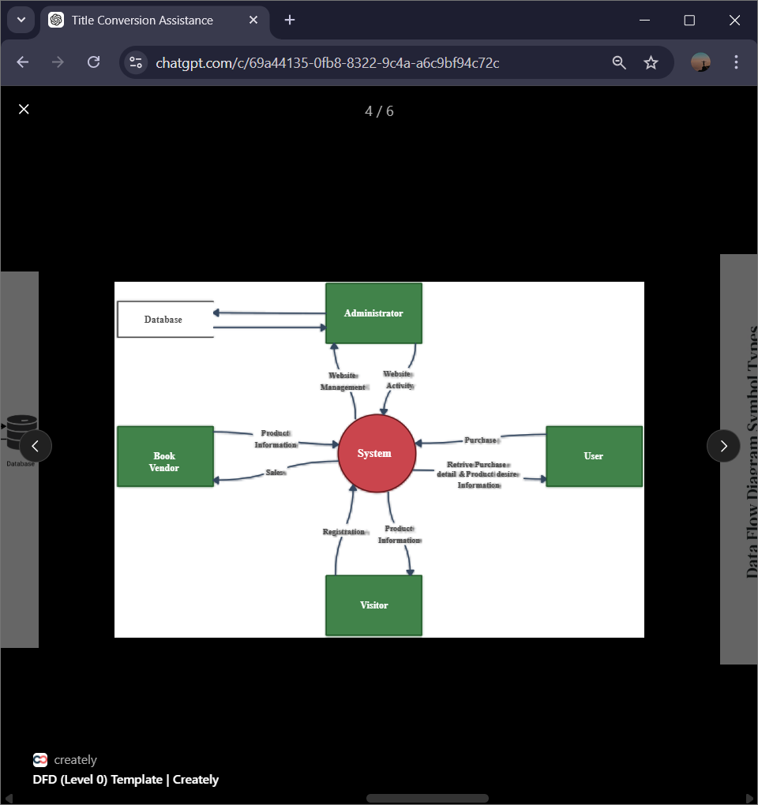

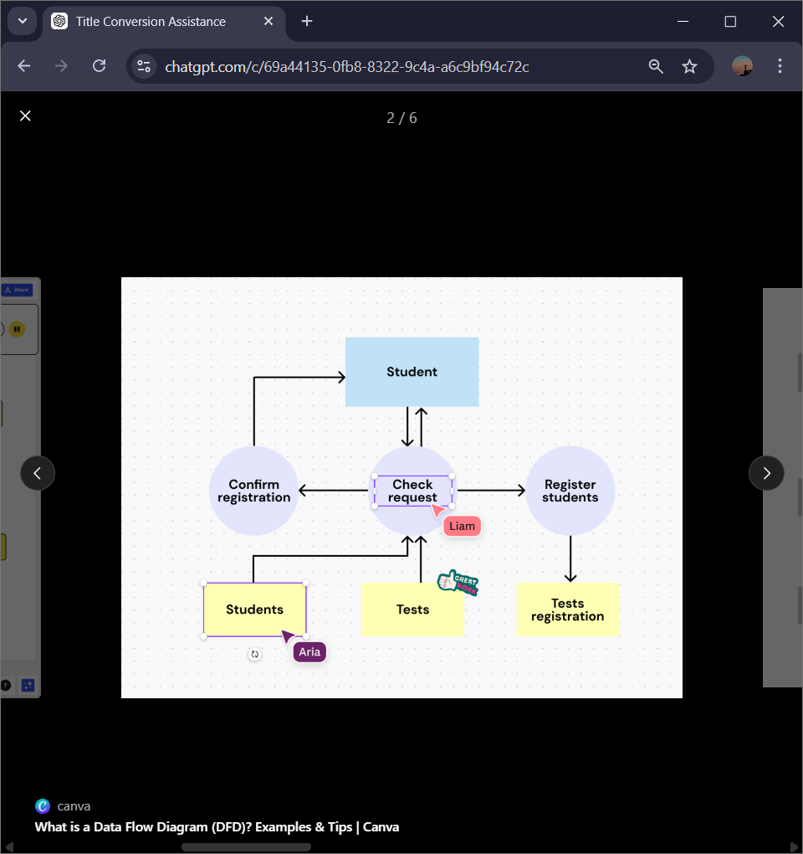

User Stories
Use the below template to list all the user stories for the product.
User Type | Functional Requirement (Epic) | User Story Number | User Story / Task | Acceptance criteria | Priority | Release
Customer (Mobile user) | Registration | USN-1 | As a user, I can register for the app by entering my email, password, and confirming my password | I can access my dashboard after registration | High | Sprint-1
 |  | USN-2 | As a user, I will receive a confirmation email after registration | I can receive confirmation email and click confirm | High | Sprint-1
 |  | USN-3 | As a user, I can register for the As a user, I can register through Google or Facebook login through Facebook | I can register & access dashboard via Google/Facebook | Medium | Sprint-2
Login | Login | USN-4 | As a user, I can log into the app by entering my email & password | I can access my dashboard securely | High | Sprint-1
Dashboard | View courses | USN-5 | As a user, I can view all available courses based on my interests | Courses are displayed with details (title, duration, skill level) | High | Sprint-1
Dashboard | Enroll in courses | USN-6 | As a user, I can enroll in selected courses | Enrollment confirmation appears and progress tracking starts | High | Sprint-1

